

**Lecture with Computer Exercises:**

**Modelling and Simulating Social Systems**

Project Report

**The characterization and application of network resilience under financial crisis**

Jingyi Liao, Yixi Li & Yuan Cui

Zürich

Date: 09/12/2018

The characterization and application of network resilience under financial crisis



**Agreement for free-download**

We hereby agree to make our source code of this project freely available for download from the web pages of COSS. Furthermore, we assure that all source code is written by ourselves and is not violating any copyright restrictions.

Names：JINGYI LIAO, YIXI LI, YUAN CUI

Content

Abstract - 1 -

Individual contribution - 2 -

1. Introduction and Motivations - 3 -

2. Model description and implementation - 4 -

2.1 Build network - 4 -

2.1.1 Network topologies - 4 -

2.1.2 Dynamic properties - 4 -

2.2 Influence of resources on network resilience - 4 -

2.3 Case study - 5 -

3. Simulation results and discussion - 6 -

**3.1** **Network build** - 6 -

3.2 Influence of resources on network resilience - 7 -

3.2.1 Scenario without stimulation - 7 -

**3.2.2** **Scenario with stimulation** - 8 -

3.3 Case study - 10 -

3.4 Discussion - 13 -

4. Summary and Outlook - 14 -

References - 15 -

# Abstract

The resilience and vulnerability of the network has been a hot topic in recent years. In this thesis,

the effectiveness of a recovery strategy for a dynamic model of failure disruption in networks is studied .Based on B. Lubos’s research, performances of three network structures (Erdős–Rényi network, scale-free network as well as small-world network) and the principle of resource allocation are researched and discussed. Specific parameters are adjusted and the network complexity are evaluated respectively for the 3 networks. The impact of models' self-resilience as well as resource allocation on network resilience are analysed. The model is then implemented to discuss the companies’ resilience in face of the financial crisis. The scale-free network is selected in the case study of Wanda Group which is composed of 8 subsidiaries. Based on the generated network, the rules on resources allocation versus capital loss and are verified and proper strategies on the future capital allocation of the company are proposed. The practical meanings of prompt response and the optimal resource input time are given at the end of the thesis.

Keywords: Network resilience, self-recovery, financial crisis

# Individual contribution

Proposal & Fresh talk: Jingyi Liao & Yixi Li & Yuan Cui

Model simulation: Jingyi Liao

Data searching and Report writing: Yixi Li & Yuan Cui

Presentation making: Yixi Li & Yuan Cui & Jingyi Liao

# 1. Introduction and Motivations

Recent industry examples highlight the challenges that companies face in recovering from a disruption. For instance, Toyota had a supply network disruption in the aftermath of the 2011 tsunami in Japan. This poses challenges to the companies’ reaction towards the crisis. Resilience, an indicator of the capacity to undergo deep change without or prior to a crisis, has been widely used as a parameter to examine the ability to stabilize within a system. The scientists have taken various perspectives on examining disruptions and resilience [2]. So far, scholars recognize the importance of understanding supply network disruptions and resilience for market forecast. However, few studies have been extended to the interaction between disruption and resilience among companies that are interrelated. Studying the performance of the company group and the effectiveness of the recovery strategy could provide theoretical basis for the decision-making of the company.

The efficient distribution of resources is also a challenging problem related to complex networks. The examples include social networks, epidemic spreading networks, and communication systems. Scientists have studied the structures and processes of these complex networks. The efficient recovery strategies for a dynamic model of failure spreading in business are vital topics with practical implementations in real world.

In related to business prospective, researches have been done on the effectiveness of customers recovery in multi-service problems. Mattila et.al (2001) examined the mechanisms of two situational factors, the service type and magnitude of failure, moderate customer responses to service failures in complex Networks and provided support to the notion of context‐specificity of service recovery [1].

In today’s hyper-competitive financial market environment, sustainable financial situations such as turnovers and cash flows are essential for company to survive. Financial failures, however, have potential to destroy not only the company but also the whole industrial ecosystem. Hence, in contrast to the pervious works, the thesis would like to focus on inter dependent systems and on the dynamics of recovery from financial crisis events between components implementing different network models, Erdös-Rényi networks, scale-free network and small-world network. Within an ecosystem in the enterprise, subsidiaries are strongly corelated with others. For every single subsidiary, the complex relations with the others include business co-operations and interdependence of capital chain. For example, in the situation of one subsidiary is lack of cash flow without warming, other subsidiaries, even the whole enterprises ecosystem and the parent company could fall into crisis as well. Therefore, in the study, the thesis would like to accentuate the resilience and self-recovery capacity of subsidiary when facing disruption from peers and their response to the effective resource distributions. The research work of the thesis aims at finding an optimal solution for resource distribution base on the idea of sustainable operation.

An experimental study under a real financial crisis condition is almost impossible, and hence, mathematical models are useful tools to extend the experiments. In this study, three independent complex network models are chosen to represent different real-world conditions. Graph theory has always been used to represent real-life scenarios theoretically. As each network can be represented as a graph, it has very wide application in network science – to calculate the shortest one or to search for critical edges (bridges) or critical nodes, called articulation points, evaluate some topological parameters or even to predict future development of the structure. As diversified networks are universally driven by a common set of laws and principles, there are general models that can describe them. In the model of Erdős and Rényi, all graphs on a fixed vertex set with a fixed number of edges are equally likely. Small-world networks and scale-free networks are important complex network models with massive number of nodes and have been actively used to study the network topology of brain networks, social networks, and wireless networks [3]. In addition, entropy of out-degree is innovatively introduced in the model to measure and probability and degree of freedom of out-degrees. And a weighting factor is inserted to limit the influence of external irritations.

Then we implicate the model into an ecosystem of one of the Fortune Global 500, Wanda Group, using scale free network, to analysis the recovery response to cascading crisis disruption. Wanda Group covers a diverse range of business and each of type of a business is operated by one subsidiary and the group has followed a sequential resource distribution strategy, which matches the assumption mentioned above. The real-estate subsidiary is the core of Wanda Group, and it has the highest impact to the rest parts of Wanda Group. Hence, the model input disruptions to the real-estate subsidiary to examine the resilience and self-recovery capacity within the Group, as well as responses to resource incentives. The impact factors such as the deflation fiscal policy by the government, the decrease of residents’ disposal income, and the increase of marginal cost of real-estate construction will be considered as dominant disruptions in a quantitate way.

# 2. Model description and implementation

## 2.1 Build network

The thesis is established on the basis of B. Lubos’s research[4]. There are three parts of the thesis in total. The first part draws lessons from the modelling ideas in this paper, including the choice of network structure, the principle of resource allocation, etc. To extend further, the specific parameters are adjusted and the network complexity is evaluated. The second part focuses on three models’ self-resilience as well as the impact of resource allocation on network resilience. In the third part, 8 subsidiaries of Wanda Group are selected as the case study to verify the second part and give corresponding suggestions on the future capital allocation of the company.

### 2.1.1 Network topologies

To capture the interactions between all the nodes and links in a complex network, a suitable model should be decided. We considered Erdős–Rényi network[5], scale-free network[6] as well as small-world network[7]. The model is based on a graph G = (N , S) of interconnected system components i∈N = {1, . . . , n}[4]. The links S together with nodes N represent structural and functional relationship inner the network. The state of a node i at time t is described by a variable xi(t), where xi = 0 corresponds to a normal functioning of the component. The deviation from this state represents to which extent the system node i is influenced[4].

### 2.1.2 Dynamic properties

Firstly the dynamic properties, such as out-degree distribution and structure complexity, of 3 networks were tested with the study of 1000 nodes and with the same expected average out-degree (20) for better comparison between 3 networks. In the scale-free network, the node initial number was 40 and the initial probability was 0.3. Ten new nodes will be added according to the dependence between the existing nodes until 1000 nodes are reached. The higher out-degree of certain node, the higher dependence. As for the small-world network, its node neighbor was 10 and reconnect probability was 1.

To measure the degree of freedom, the structure entropy was calculated with Eq. (1)[9]. Assume a system X has n sub-states X1, X2, ..., Xn, and the substate Xi has a probability of *p(i)* which satisfies  . A more complex network has higher structure entropy. The sub-states in the thesis are determined by the out-degree of the network and every unique out-degree represent a certain sub-state.



(1)



## 2.2 Influence of resources on network resilience

Then the networks’ efficiencies of disaster recovery in scenarios without and with stimulation are discussed. Disturbance spread through links and influence other nodes. Nodes’ recovery efficiencies from and resistances to one disturbance occurred on a single node were evaluated. For intuitive display, small networks of 12 nodes were selected for analysis. A disturbance of - 0.3 was implemented in one node and the damaged point threshold is set as - 0.2 where the rest nodes were thought of lack enough recovery ability.

The network’s natural level of resistance to challenges is described by the sigmoidal function Eq. (2), where α is a “gain parameter” and θ(i) equals 0.

(2)



The interactions between the components are quantified by the connection strengths Mij and by the link transmission time delays tij > 0. The overall dynamics of a node is then given by Eq. (2). The thesis modifies Eq. (2) with a new parameter – constraint factor *w* ranging from 0 to 1 to limit the influence between nodes under 1. The first part of the right side of Eq. (2) represents the node’s self-recovery ability from disturbance. The recovery rate 1/τi characterizes the speed of the recovery(recovery rate). The second part quantifies the dependence between nodes and the delay effect occurring during disturbance spreading in the network. The parameter βtji corresponds to the disturbance spreading delay. **Θj** is the out-degree of node j.

(3)



With Eq. (2) and Eq. (3), the number and degree of influenced nodes in the scenario without stimulation are quantified.

Then an external stimulation described with Eq. (4) is implemented to promote the networks’ recovery from challenges, with amplitude a1=100, b1=3, c1=2. The stimulation is intermittently implemented in 40 time steps and the time interval is defined as 0.1 (T=0.1:0.1:4). Resources *Ri* such as funds was proportionally allocated to nodes in term of weights of out-degree. According to Eq. (5), invested resources will strengthen nodes’ resistance and recovery ability.

(4)



(5)



With Eq. (2)-(5), the number and degree of influenced nodes in the scenario without stimulation are quantified.

## 2.3 Case study

The effect of stimulation amplitude and time on network’s recovery ability was discussed in a case study of Wanda Group. An interdependent industrial chain in Wanda Group composed of 8 companies is simulated as a scale-free network. Their recovery efficiency from and resistance to funds short of one subsidiary is evaluated.

A disturbance of reducing benefit by 30% was implemented in the real estate company. In the scenario without stimulation, 8 companies’ benefits and expected loss were calculated to present their recovery ability. In the scenario with stimulation, funding was proportionally allocated to 8 companies to promote their recovery concerning their out-degree values calculated with scale-free generation model. The influence of different resource amplitude and resource start time on the total loss is also studied, which helps to give Wanda group a more effective resource allocating solution.

# Simulation results and discussion

* 1. **Network build**

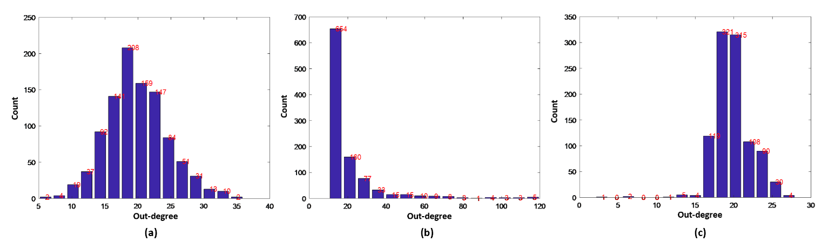

Figure 1. Out-degree frequency histogram of (a) Erdős–Rényi network, (b) scale-free network and (c) small-world network

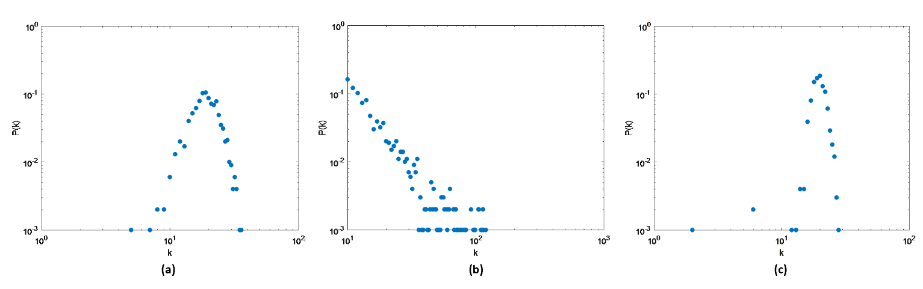

Figure 2. Connectivity distribution P(k) of (a) Erdős–Rényi network, (b) scale-free network and (c) small-world network

Figure 1 and 2 shows the out-degree aggregation of the three different networks. In Figure1, the abscissa represents the out-degree value, and the ordinate represents the corresponding node number to an out-degree. For example, when the out-degree equals 10 in the Erdős–Rényi network, the corresponding number of nodes is 10. The abscissa in Figure 2 is the out-degree values, and the ordinate is the corresponding probability. Therefore, by comparing the out-degree of three networks as shown in Figure 1 and 2, it can be seen that Erdős–Rényi network presents a normal distribution, that is, resource allocation is relatively even. Scale-free and small-world networks, however, are more centralized.

Table 1. Actual out-degree and structure entropy of 3 networks

|  |  |  |  |
| --- | --- | --- | --- |
| Network types | Erdős–Rényi Network | Scale-free Network | Small-world Network |
| Actual out-degree | 19.86 | 19.64 | 19.86 |
| Structure entropy | 4.15 | 4.55 | 3.22 |

Table 1 shows the average out-degree and calculated structure entropy. When the three networks’ average out-degree are all around 20, the scale-free network model has a highest structure entropy, which means its system has a biggest degree of freedom for its out-degree distribution. On the other hand, the small-world network has the lowest structure entropy so it has a smallest degree of freedom. In the large number test, it could always be achieved that the small-world network has the smallest entropy.

## Influence of resources on network resilience

### 3.2.1 Scenario without stimulation

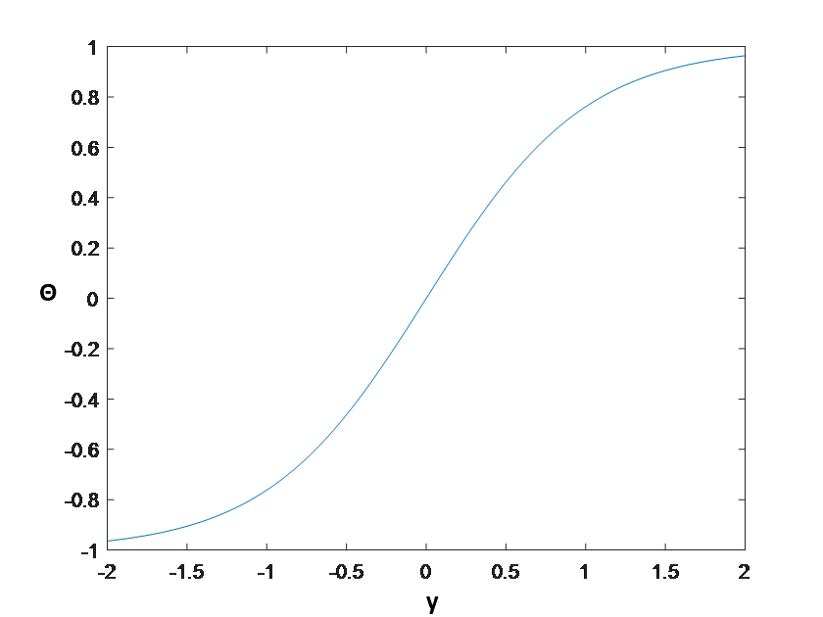

Figure 3. Sigmoidal function curve

Figure 3 shows the natural level of resistance to challenges increase with increasing input, which means that the negative input will always draw to the negative output. The influence of other nodes is carefully calculated to be posed on the studied node.

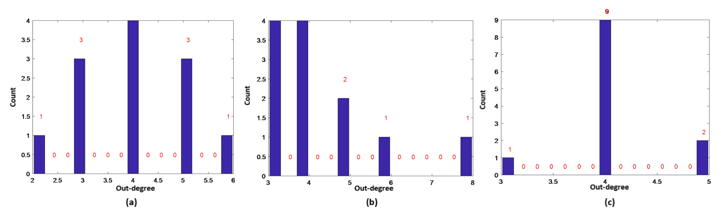

Figure 4. Out-degree frequency histogram of (a) Erdős–Rényi network, (b) scale-free network and (c) small-world network

Figure 4 shows the frequency histograms of out-degree for three types of 12-node networks. The out-degree aggregation for the three networks in Figure 4 correspond to Figure 1-2 in section 3.1.

Table 2. Actual out-degree and structure entropy of 3 networks

|  |  |  |  |
| --- | --- | --- | --- |
| Network types | Erdos-Renyi Network | Scale-free Network | Small-world Network |
| Actual out-degree | 4.00 | 4.33 | 4.08 |
| Structure entropy | 2.13 | 2.09 | 1.04 |

The calculated structure entropy of three networks in Table 2 is also in the same rules with Table 1. The scale-free network has a larger average out-degree value, indicating that the scale-free network is more interconnected and its out-degree distribution is much more complex than the small-world network.

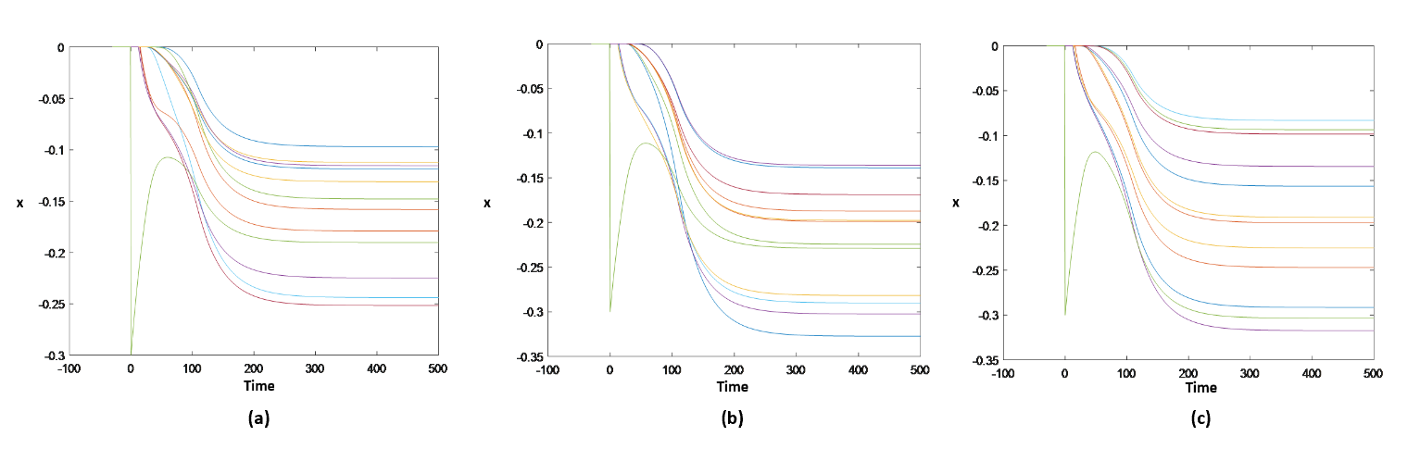

Figure 5. Node state vs. time in scenario without stimulation of (a) Erdős–Rényi network, (b) scale-free network and (c) small-world network

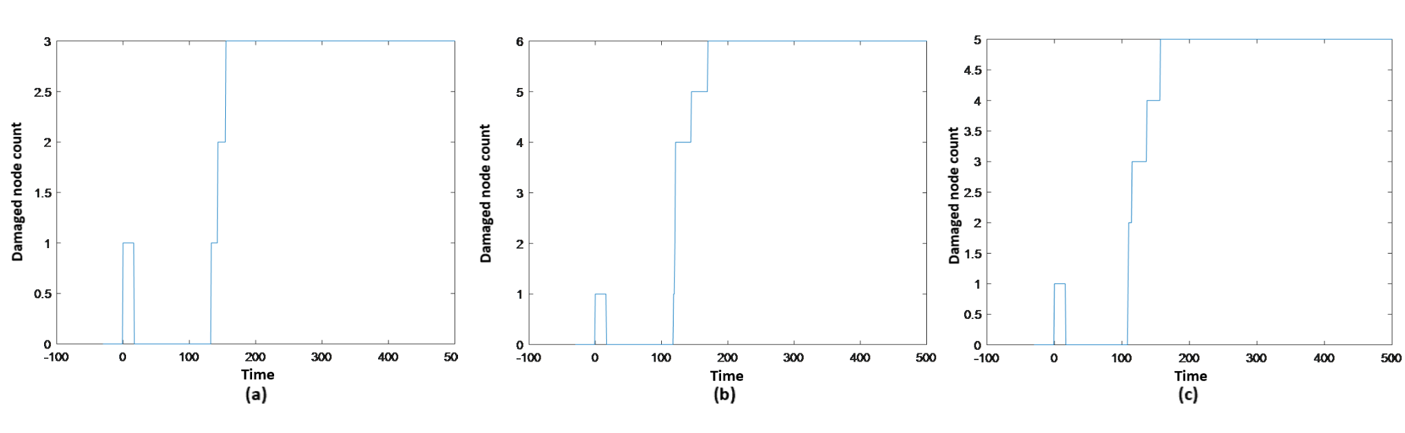

Figure 6. Damaged node count vs. time in scenario without stimulation of (a) Erdős–Rényi network, (b) scale-free network and (c) small-world network

Figure 5 plots the node state xi varying with time. Figure 6 plots the number of destructive node at certain time. After implementing a disturbance of - 0.3 on single node at 0 time (the green line in Figure 5), this node starts recovery from the challenge and other 11 nodes show different degree of damaging due to disturbance spreading through the network. Figure 6 illustrates the number of node that bellow the damaged point 0.2 varying with time.

* + 1. **Scenario with stimulation**

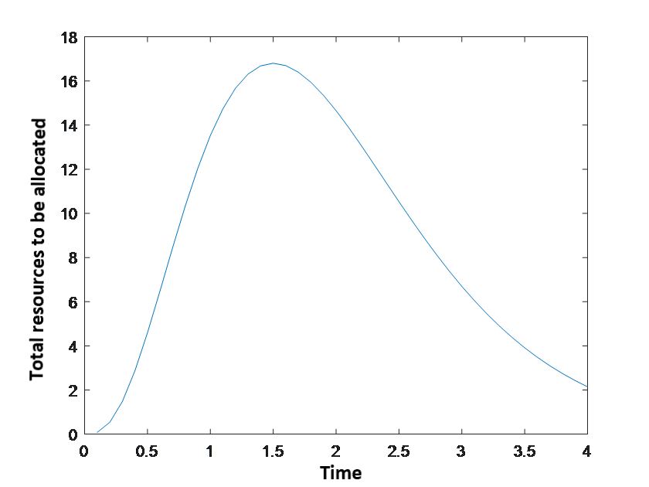

Figure 7. Stimulation addition curve

Figure 7 visualizes Eq. (4) and gives an idea how the total resources to be allocated vary with time.

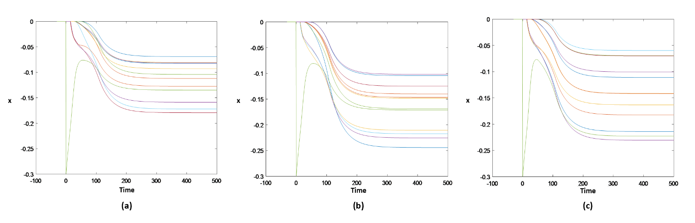

Figure 8. Node state vs. time in scenario with stimulation of (a) Erdős–Rényi network, (b) scale-free network and (c) small-world network

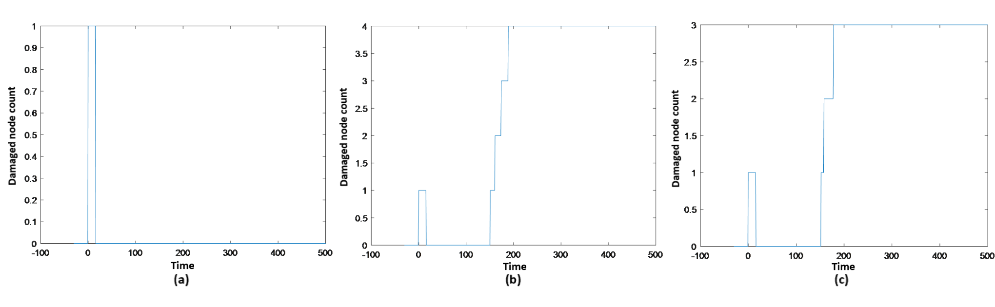

Figure 9. Damaged node count vs. time in scenario with stimulation of (a) Erdős–Rényi network, (b) scale-free network and (c) small-world network

Figure 8 shows how the 12 nodes get influenced with stimulation measure, after the implementation of disturbance on one node at time 0. Compared to Figure 5 (scenario without stimulation), the node disturbed directly (represented by the green line) in stimulation scenario recovers much faster. Figure 9 plots the number of destructive nodes at certain time. Compared to Figure 6, there are less nodes getting below the damaged point threshold -0.2 in the stimulation scenario. Thus, the stimulation measure efficiently improved networks’ self-recovery ability as well as the resilience to disturbances for all the three networks discussed.

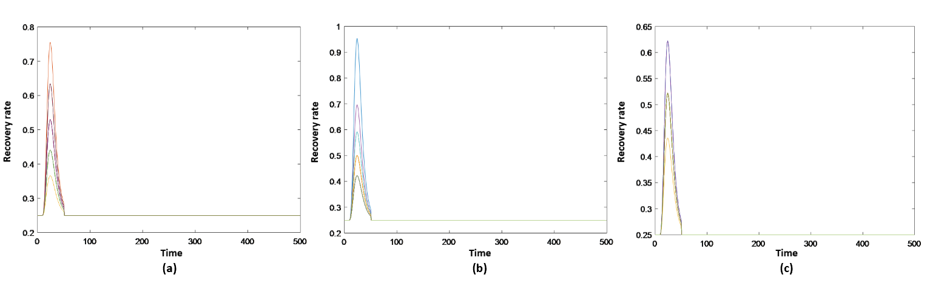

Figure 10. Recovery rate vs. time in scenario with stimulation of (a) Erdős–Rényi network, (b) scale-free network and (c) small-world network

Figure 10 shows the recovery rate of every node versus time. From Figure 10, the recovery rate reaches its peak shortly after the stimulation, then it decreases to the initial value after the stimulation stopped.

## 3.3 Case study

Table 3. Out-degree of 8 companies in Wanda Group

|  |  |  |  |  |  |  |  |  |
| --- | --- | --- | --- | --- | --- | --- | --- | --- |
| Company | Rental | Real estate | Film | Sports | Finance | Internet technology | Culture | Baobeiwang |
| Out-degree | 2 | 5 | 4 | 3 | 3 | 2 | 2 | 1 |

Table 3 is the out-degree values of the eight companies in the Wanda Group induxtrial chain, which are generated from the free-scale network model. Resources allocation was based on this table. Higher out-degree represents higher dependence of this node in the whole netwoek. So the node deserves more resources as stimulation to help improve its self-recovery and resillience ability. Here the real estate company has the largest out-degree, so it is the highest connected company in the 8 companies’ network.

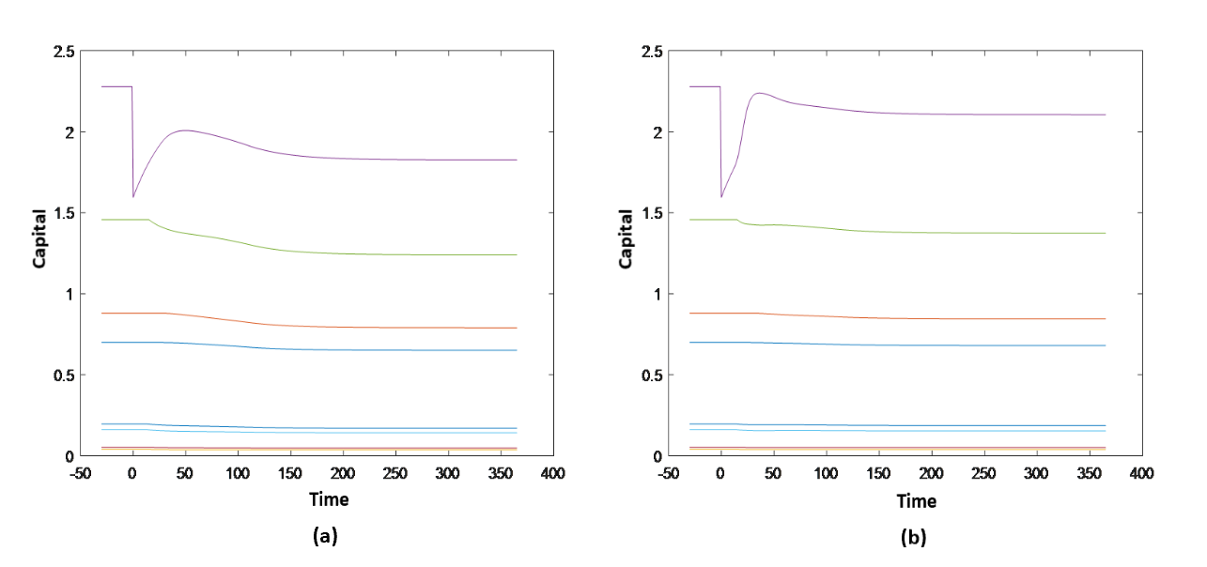

Figure 11. Capital vs. time curve of 8 companies in scenarios (a) without stimulation and (b) without stimulation

After suffering a 30% decrease of capital in the real estate company (the purple line in Figure 11), the capital changes in all the companies with time are shown in Figure 11. The capital of the real estate company in scenario with stimulation recovered faster and to a higher level than without stimulation. Besides, the rest seven companies experienced a slighter decline of capital in the stimulation scenario. From which, it can be said that the stimulation measure can significantly improve the resistance to the challenge and enlarge the recovery ability of these companies.

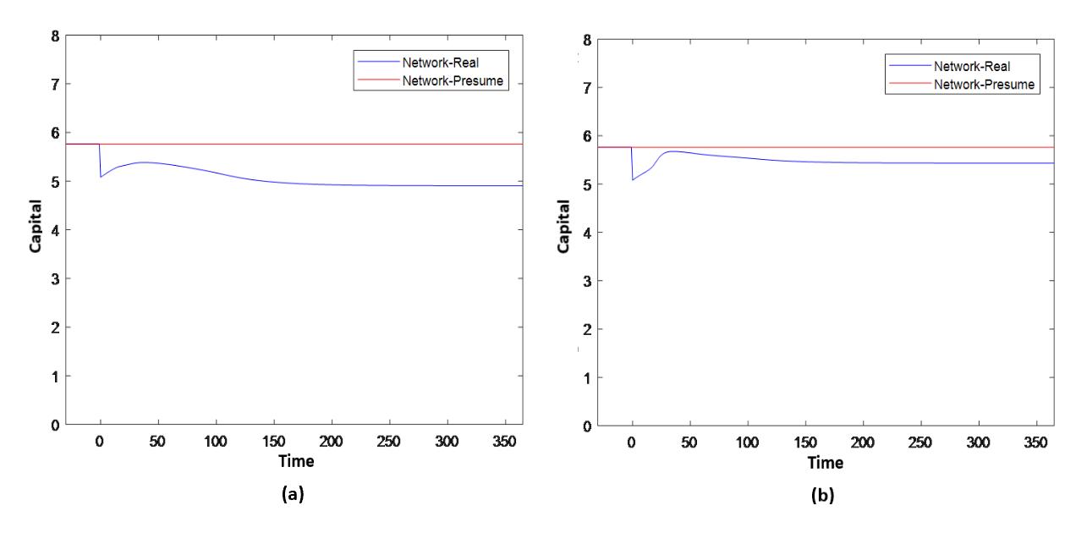

Figure 12. Capital vs. time curve of Wanda Group in scenarios (a) without stimulation and (b) without stimulation

Table 4. Capital loss of 8 companies in scenario without stimulation

|  |  |  |  |  |  |  |  |  |  |
| --- | --- | --- | --- | --- | --- | --- | --- | --- | --- |
| Company | Sports | Finance | Baobeiwang | Real estate | Film | Internet | Culture | Rental | Sum |
| Actual capital | 71.80 | 321.20 | 14.40 | 831.70 | 532.00 | 58.60 | 19.50 | 255.20 | 2104.40 |
| Expected capital | 64.57 | 298.33 | 13.60 | 685.03 | 471.23 | 53.56 | 17.78 | 243.24 | 1847.33 |
| Difference | -7.23 | -22.87 | -0.8 | -146.67 | -60.77 | -5.04 | -1.72 | -11.96 | -257.07 |

Table 5. Capital loss of 8 companies in scenario with stimulation

|  |  |  |  |  |  |  |  |  |  |
| --- | --- | --- | --- | --- | --- | --- | --- | --- | --- |
| Company | Sports | Finance | Baobeiwang | Real estate | Film | Internet | Culture | Rental | Sum |
| Actual capital | 71.80 | 321.20 | 14.40 | 831.70 | 532.00 | 58.60 | 19.50 | 255.20 | 2104.40 |
| Expected capital | 69.01 | 312.80 | 14.09 | 771.92 | 509.58 | 56.67 | 18.86 | 251.01 | 2003.94 |
| Difference | -2.79 | -8.40 | -0.31 | -59.78 | -22.42 | -1.93 | -0.64 | -4.19 | -100.45 |

Figure 12 shows how the total capital changes in Wanda Group with time. The red curve depicts the predicted capital without disturbance and the blue curve depicts the predicted capital suffering disturbance. By integrating the differences between the red and blue curves, the capital loss due to capital reduction in the real estate company was calculated as listed in Table 4-5. Accordingly, in the stimulation scenario, the group’s capital experiences a smaller loss and a much faster and better recovery compared to the scenario without stimulation.

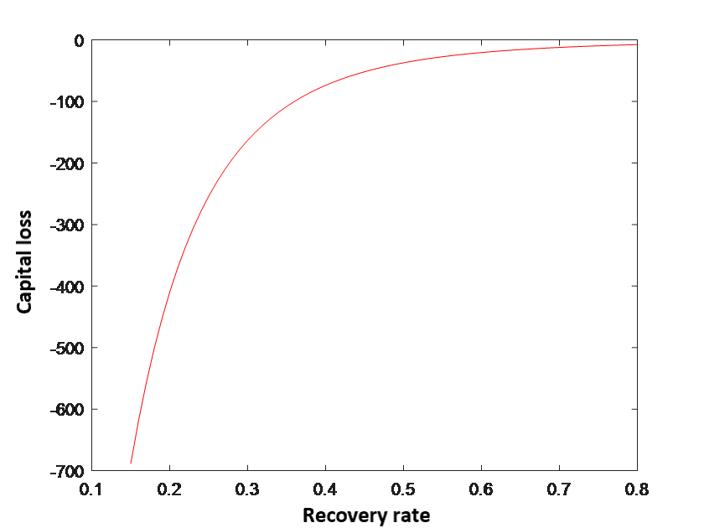

Figure 13. Recovery rate vs. capital loss

Figure 13 means that the higher recovery rate, the less capital loss.

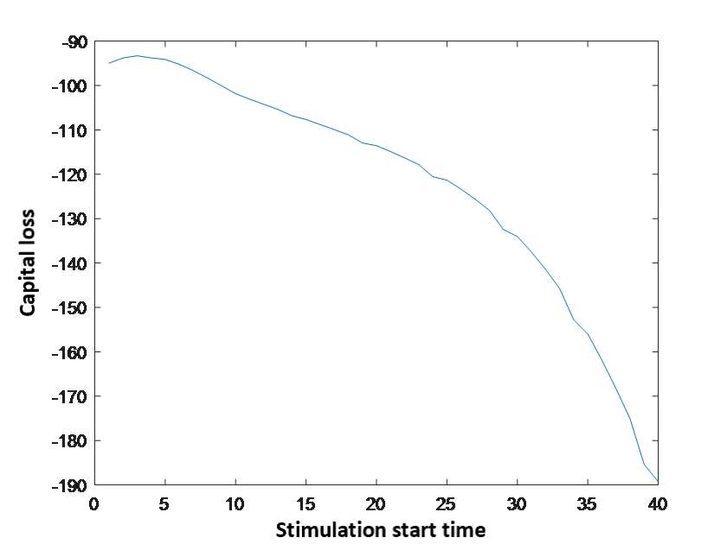

Figure 14. Stimulation start time vs. capital loss

Figure 14 shows that implementing the stimulation as early as possible is favourable to reduce the capital loss. Starting the stimulation before spreading of disturbances could be a very efficient choice. The delayed stimulation measure may have very limited effect because the disturbance already spread through the network.

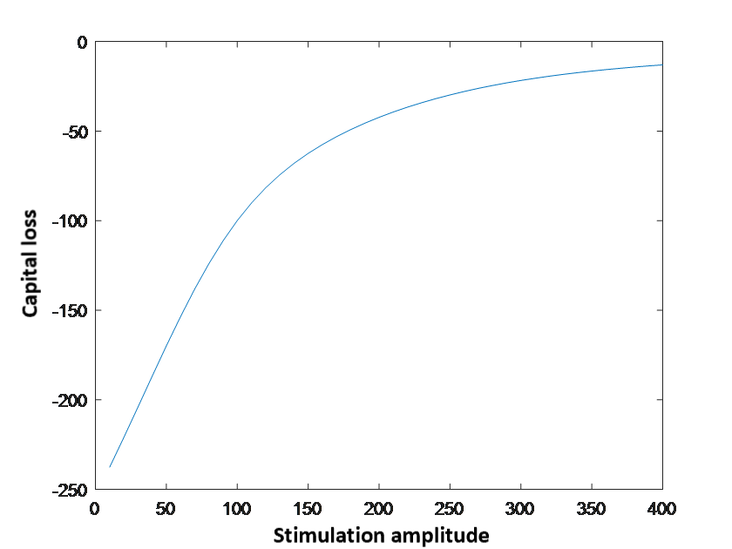

Figure 15. Stimulation amplitude vs. capital loss

Figure 15 shows how the adjustment of amplitude of resources input affect the capital loss. The capital loss decreases with increasing amplitude in a non-linear way. This curve can help determine a best strategy considering both the cost of resources input and the capital loss prevention.

## 3.4 Discussion

External financial disruption and the operation of inter-connected infrastructures involve an intricate decision making where each action can invoke a variety of unpredictable reactions. Here, different network type plays an important role as they could estimate different situations in real-world, and the complex systems theory as well as the statistical physics of networks offer powerful validity of the results. These allow one to gain comprehensive understanding of the dynamics of financial crisis and to derive valuable results to minimize the loss.

The group project work specifically focuses on the implications of the vulnerability and resilience in Erdös-Rényi network scale-free network and small-world network. And the work involves the efficiency of a strategy to distribute resources for the recovery of financial-crisis-disruption networks. This resource allocating strategy depends on network complexity, specifically, node’s out-degree. In the first part of the results, the work aims at validating the dynamic properties of the three network models to confirm the effectiveness of self -recovery. The dynamic properties, out-degree and entropy show that in most cases, small-scale network has the highest degree of complexity, while Erdös-Rényi networks is the second and small-world network is the less complexity one. Hence, when doing real case simulation, different model could be chosen to fulfil different preference. And in this case, to make it closer to Wanda Group’s situation, scale-free model is used to implicate in the simulation.

Under the condition that no external incentive is made, every node is influenced by the disruption occurred in the selected node. An explicit resilience curve could be observed and the result indicates that extra resources are needed to prevent the point fall into an incurable damage level despite self-recovery. Under the condition that external incentives are inserted, all networks respond effectively to the incentive action, and obviously the number of points that stay in the incurable damage level decrease in every network. The results declare that external resources feed in is an effective option to rescue points from permanent damage. However, the resource feed-in is not a panacea to disruption. Only limited positive impact could happen under scale-free network and small-world model, which is closer to the realistic situation. Hence, it is recommended to use scale-free network and small-world network to estimate a real case study.

Then an implementation of the vulnerability and resilience concept with the adaptations of the operating estimations of subsidiaries within Wanda Group is performed. In this case, disruption with extra incentives case perform better self-recovery behaviors in a shorter time scale. Although with no external incentive, the sample company shows a self-resilience, to maintain the minimal loss of capital, it is recommended to input external incentive.

When the responses time delay and distribution of resources are limited in reasonable ranges, the threshold point in simulation time has the optimized effect. It is recommended company could follow the capital loss and the response time curve to determine the optimal time to feed in resources. The reason why a threshold point occurs in the simulation could be discuss in the future study. Also, the response under Erdös-Rényi network and small-world network to financial crisis could also be a meaningful question in future study.

# Summary and Outlook

The project could be divided into two parts. The first part of the project aims at reproducing the dynamic properties of complex networks. The results show that Erdös-Rényi network, scale-free network and small-world network shows the vulnerability when suffered from disruption. They have the capacity of self-recovery and would have a better performance if extra resource incentives are added.

The second part is an implementation that adapting Wanda Group’s situation to a scale-free network and analysis the vulnerability and resilience of companies under financial crisis. The result confirms the effeteness of resource feed-in and give an optimal time point that the company could have the smallest loss of capital under same amounts of resources fed in. Hence, when analyzing the business performance and the ability to maintain stability of relevant companies, complex network could be implicated to forecast the changes with or without resources response.

Finally, the outlooks of the study are listed as follows,

* It would be meaningful to extend the implementation range by taking the non-self-recovery systems into account. Since these models are limited and can only implicate in systems with self-recovery capacity.
* Research could not only focus on the companies in the same Group but could also focus on a peer industry scale. For example, how will the bankrupt of a major manufacture influence the whole industry and how will other manufacture response to this irritation.
* It would also make sense for a government and central bank to study the efficiency of the resource distribution when incentives from the national scale are required by the market.

# References

[1] Mattila A S. The effectiveness of service recovery in a multi-industry setting[J]. Journal of Services Marketing, 2001, 15(7): 583-596.

[2] Mirchev D E M J. ON THE SPECTRA OF SCALE-FREE AND SMALL-WORLD NETWORKS СПЕКТРАЛЕН АНАЛИЗ НА SCALE-FREE И SMALL-WORLD МРЕЖИ[J].

[3] Kim Y, Chen Y S, Linderman K. Supply network disruption and resilience: A network structural perspective[J]. Journal of operations Management, 2015, 33: 43-59.

[4] Buzna, Lubos, et al. "Efficient response to cascading disaster spreading." Physical Review E 75.5 (2007): 056107.

[5] Erdos, Paul, and Alfréd Rényi. "On the evolution of random graphs." Publ. Math. Inst. Hung. Acad. Sci 5.1 (1960): 17-60.

[6] Barabási, Albert-László, and Réka Albert. "Emergence of scaling in random networks." science 286.5439 (1999): 509-512.

[7] Watts, Duncan J., and Steven H. Strogatz. "Collective dynamics of ‘small-world’networks." nature 393.6684 (1998): 440.

[8] Tan, Yue-jin, and Jun Wu. "Network structure entropy and its application to scale-free networks." Systems engineering-theory & practice 6 (2004): 001.

[9] HUANG, Ya-jing, and Jian-hua GAO. "Measure Method of Structural Complexity in Open Source Software [J]." *Computer Engineering* 10 (2010): 022.